Project solutions and reference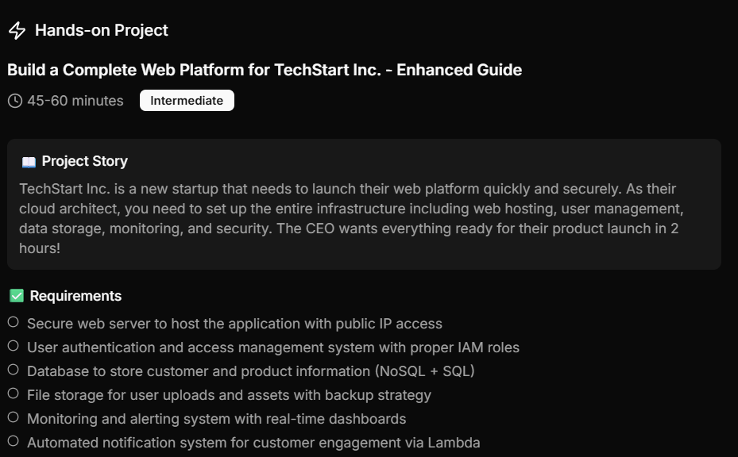
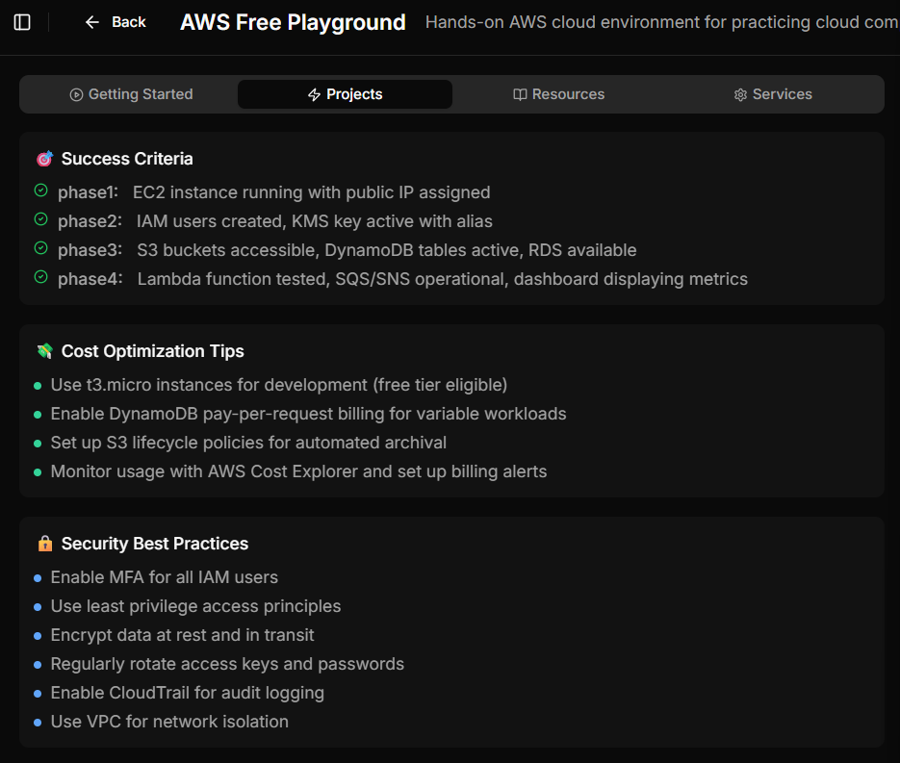
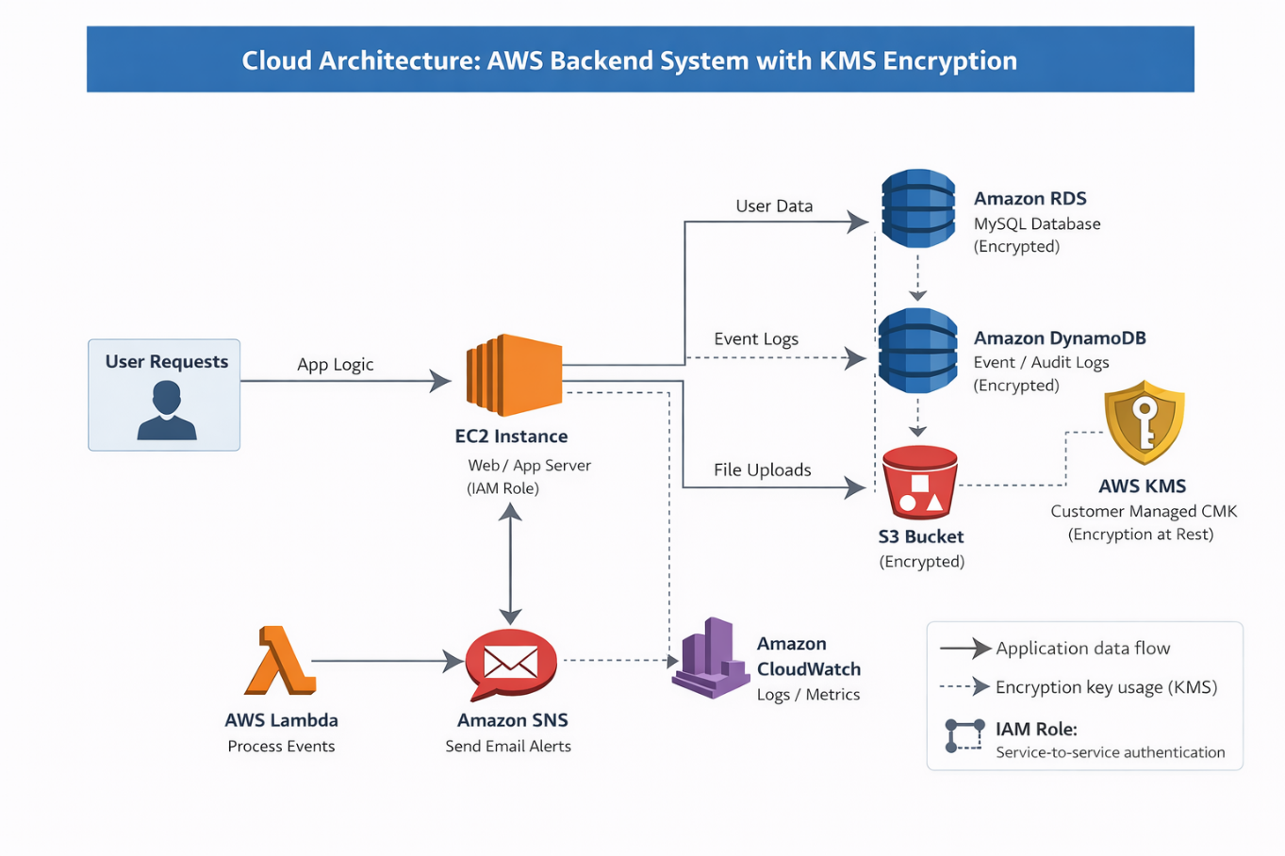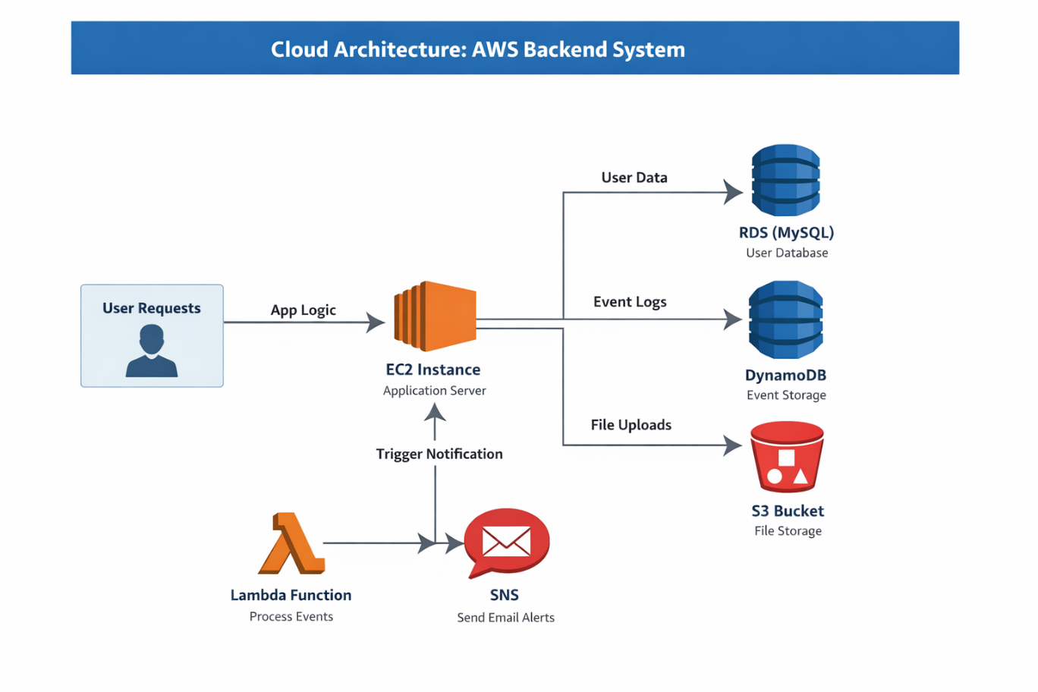
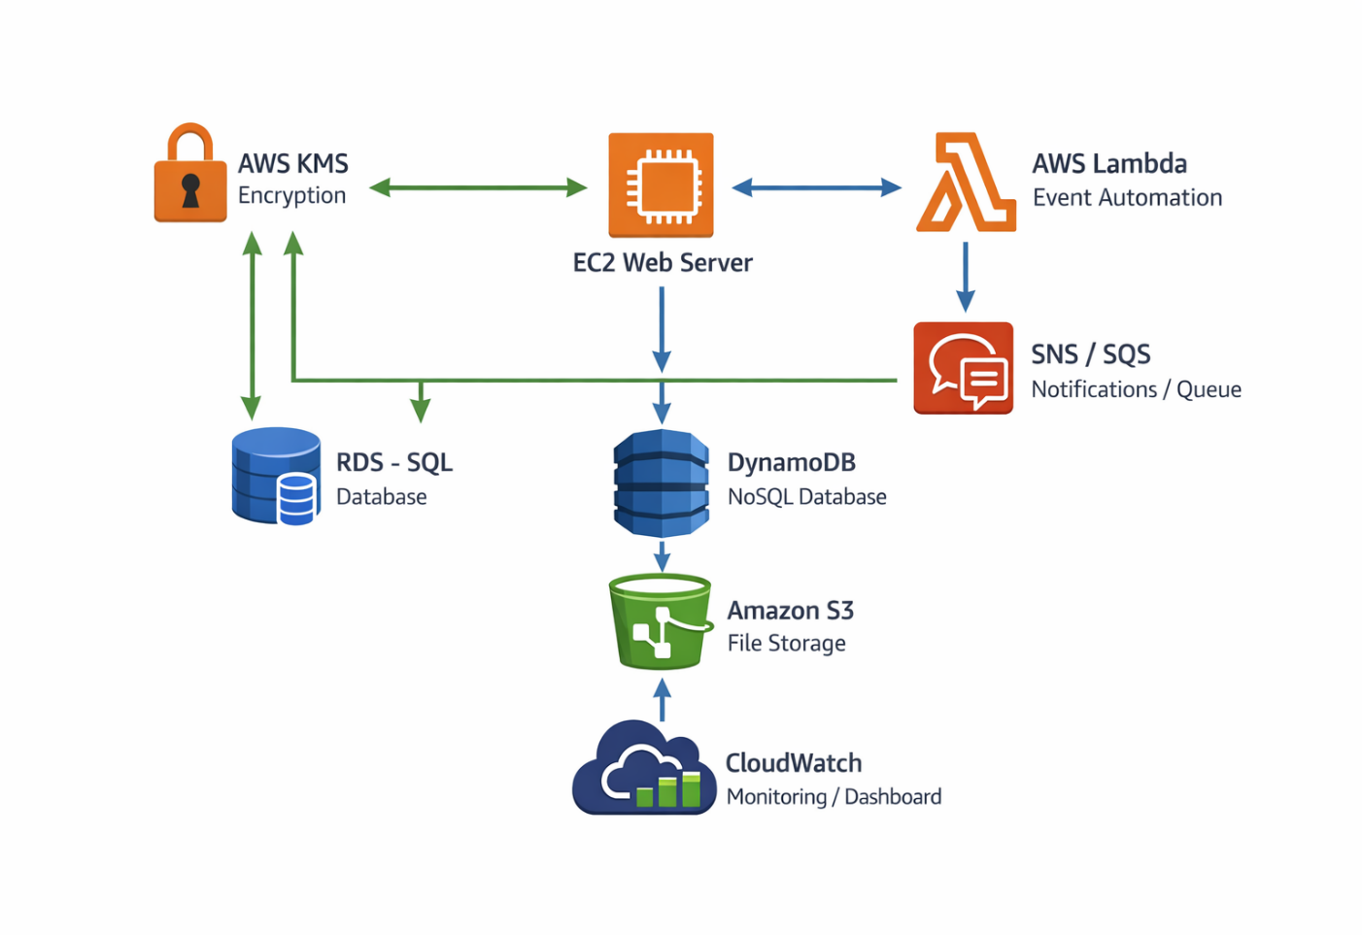Perfect — this screenshot tells me exactly what the AWS Playground expects.
Below is a phase-by-phase execution guide that maps 1:1 to the Success Criteria so you can complete the project without missing anything.
I’ll keep this hands-on, console-focused, and free-tier safe.

✅ AWS Free Playground – Project Completion Guide
🔹 PHASE 1
EC2 instance running with public IP assigned
Step 1: Launch EC2
- Open EC2 → Instances → Launch instance
- Name: techstart-web-server
- AMI: Amazon Linux 2
- Instance type: t3.micro ✅ (free tier)
- Key pair: Create or select one
- Network settings:
  - Auto-assign Public IP: Enabled
  - Security Group:
    - Allow SSH (22) from your IP
    - Allow HTTP (80) from 0.0.0.0/0
Step 2: Launch & Verify
- Wait until instance state = Running
- Copy Public IPv4 address
- Paste in browser → (will be blank, that’s OK)
✅ Phase 1 complete

🔹 PHASE 2
IAM users created, KMS key active with alias

Step 3: Create IAM User
- Open IAM → Users → Create user
- Name: techstart-admin
- Access:
  - AWS Management Console
- Permissions:
  - Attach policy: AdministratorAccess (lab only)
- Enable MFA (recommended)

Step 4: Create KMS Key
- Open KMS → Customer managed keys
- Create key:
  - Type: Symmetric
  - Usage: Encrypt & decrypt
- Alias: alias/techstart-key
- Key administrators: your IAM user
- Finish creation
✅ Key status = Enabled
✅ Phase 2 complete

🔹 PHASE 3
S3 buckets accessible, DynamoDB tables active, RDS available

Step 5: Create S3 Buckets
Create two buckets:
Bucket 1
- Name: techstart-user-uploads-<unique>
- Block public access: ON
- Enable Versioning
Bucket 2
- Name: techstart-assets-<unique>
- Enable Versioning
(Optional)
- Add lifecycle rule → transition to Glacier after 30 days

Step 6: Create DynamoDB Table
- Open DynamoDB → Tables → Create
- Table name: TechStartUsers
- Partition key: UserId (String)
- Billing mode: On-demand
Wait → Status = Active

Step 7: Create RDS Database
- Open RDS → Create database
- Standard create
- Engine: MySQL or PostgreSQL
- Template: Free tier
- DB instance:
  - Identifier: techstart-db
  - Instance class: db.t3.micro
- Enable automated backups
- Public access: No
- Security group:
  - Allow inbound from EC2 security group
Wait until status = Available
✅ Phase 3 complete

🔹 PHASE 4
Lambda tested, SQS/SNS operational, dashboard displaying metrics

Step 8: Create SNS Topic
- Open SNS → Topics → Create
- Type: Standard
- Name: techstart-alerts
- Create subscription:
  - Protocol: Email
  - Endpoint: your email
- Confirm email

Step 9: Create Lambda Function
- Open Lambda → Create function
- Author from scratch
- Name: techstart-notification
- Runtime: Python 3.10
- Permissions: Create new role with basic Lambda permissions
Lambda Test Code
import boto3

def lambda_handler(event, context):
sns = boto3.client('sns')
sns.publish(
TopicArn='YOUR_SNS_TOPIC_ARN',
Message='TechStart notification test successful!',
Subject='Lambda Test'
)
return {'status': 'success'}
- Replace YOUR_SNS_TOPIC_ARN
- Click Deploy
- Click Test
✅ Email received → Lambda working

Step 10: Create SQS Queue (Required)
- Open SQS → Create queue
- Type: Standard
- Name: techstart-queue
(Optional) Connect Lambda trigger

Step 11: CloudWatch Dashboard
- Open CloudWatch → Dashboards → Create
- Name: TechStart-Monitoring
- Add widgets:
  - EC2 CPU Utilization
  - Lambda Invocations
  - DynamoDB Read/Write
  - RDS connections
Dashboard visible = success
✅ Phase 4 complete

🏁 FINAL SUCCESS CHECK
Requirement | Status
EC2 public IP | ✅
IAM + KMS | ✅
S3 + DynamoDB + RDS | ✅
Lambda + SNS + SQS | ✅
CloudWatch dashboard | ✅
🎉 PROJECT COMPLETED

🔥 Want Extra Credit?
I can help you:
- Deploy a sample web app on EC2
- Connect EC2 → RDS → S3
- Add API Gateway
- Write Terraform / CloudFormation
- Prepare interview or exam answers based on this lab
Just tell me what you want next 👇

